

Hospital Network System
Implementation Using Cisco Packet Tracer

Computer Networks

Submitted To: Sir Ahsan Bilal Shakir

Team Members:
Muhammad Talha (23-uon-0446)
Nahah Butt (23-uon-0338)

UNIVERSITY OF NAROWAL
Department of Computer Science

1. Introduction
In modern networking, routers play a critical role in interconnecting multiple networks and facilitating the reliable exchange of data. This project focuses on designing and simulating a hospital network architecture using Cisco Packet Tracer involving two routers and multiple VLANs.

The purpose is to understand the concepts of routing, IP addressing, VLAN segmentation, and inter-network communication. By setting up two routers, each connected to its own local area network (LAN), this project simulates a real-world hospital environment where communication across different network segments is essential.

This practical approach provides hands-on experience with router configurations, routing protocols, and network troubleshooting — foundational skills in the field of networking, especially in critical domains like healthcare.

2. Objectives
- Design and simulate a hospital network using Cisco Packet Tracer
- Implement VLAN segmentation for different hospital departments
- Configure inter-VLAN routing between network segments
- Apply static or dynamic routing protocols (RIP / OSPF / EIGRP)
- Test and verify connectivity using ping and traceroute
- Demonstrate reliable communication across different LANs

3. Network Topology & Design

3.1 Overview
The hospital network is divided into six VLANs representing different hospital departments. Two core routers handle inter-network routing, connected to managed switches that distribute traffic to end devices within each VLAN.

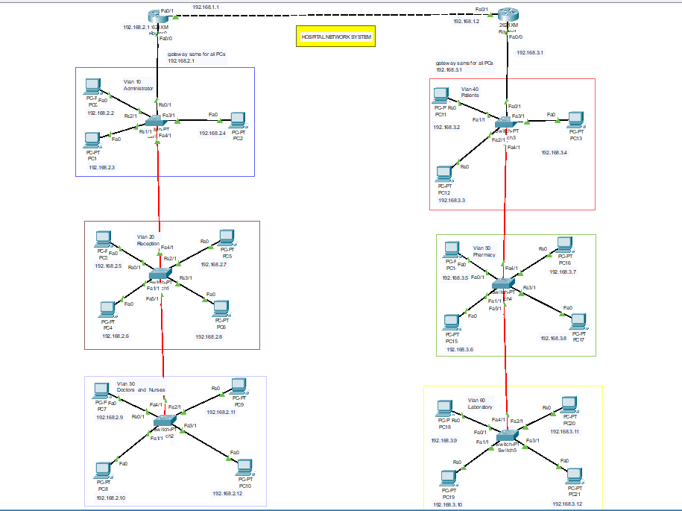
Figure 1: Hospital Network System — Cisco Packet Tracer Topology

3.2 VLAN Structure
VLAN ID | Department | Subnet | Gateway
VLAN 10 | Administration | 192.168.2.0/24 | 192.168.2.1
VLAN 20 | Reception | 192.168.2.0/24 | 192.168.2.1
VLAN 30 | Doctors & Nurses | 192.168.2.0/24 | 192.168.2.1
VLAN 40 | Patients Ward | 192.168.3.0/24 | 192.168.3.1
VLAN 50 | Pharmacy | 192.168.3.0/24 | 192.168.3.1
VLAN 60 | Laboratory | 192.168.3.0/24 | 192.168.3.1

4. Methodology
The network was designed using Cisco Packet Tracer, a simulation tool widely used for network configuration and visualization. The complete setup involved the following steps:

4.1 Physical Setup
- Placed two routers and multiple managed switches in the topology
- Connected each switch to VLAN PCs using straight-through cables
- Connected switches to routers using FastEthernet interfaces
- Connected the two routers to each other via a serial/crossover link

4.2 Router Configuration
Each router interface was configured with an IP address matching its connected subnet. The no shutdown command was used to activate all interfaces. Router 1 FastEthernet 0/0 was assigned IP 192.168.2.1/24 and Router 2 FastEthernet 0/0 was assigned 192.168.1.1/24.

4.3 VLAN & Switch Configuration
- Created VLANs 10, 20, 30, 40, 50, 60 on each managed switch
- Assigned switch ports to their respective VLANs (access mode)
- Configured trunk ports between switches and routers
- Verified VLAN assignments using the show vlan command

4.4 Routing Protocol
Static routing was configured on both routers to define paths to remote networks. Routing tables were verified using the show ip route command, ensuring all subnets were reachable from both sides.

5. Working & Verification
Once configured, the routers facilitated communication between devices in different LANs. Network functionality was verified through:

- Sending ICMP ping packets between PCs across both routers
- Running traceroute to visualize the path through the network
- Checking routing tables on each router using show ip route
- Verifying VLAN membership using show vlan on each switch
- Confirming that inter-VLAN traffic correctly passed through the router

All ping responses were successful, confirming that packets traversed the network correctly. Routers read destination IP addresses, determined the correct next-hop interface, and forwarded packets accordingly.

6. Configuration Details

6.1 Router 1 — CLI Commands
Router> enable
Router# configure terminal
Router(config)# interface FastEthernet 0/0
Router(config-if)# ip address 192.168.2.1 255.255.255.0
Router(config-if)# no shutdown
Router(config-if)# exit
Router(config)# interface FastEthernet 0/1
Router(config-if)# ip address 192.168.1.1 255.255.255.0
Router(config-if)# no shutdown

6.2 Active VLANs (show vlan output)
The show vlan command confirmed all VLANs were active: VLAN 10 (Administrator), VLAN 20 (Reception), VLAN 30 (Doctors and Nurses), VLAN 40 (Patients), VLAN 50 (Pharmacy), VLAN 60 (Laboratory).

7. Conclusion
The Hospital Network System project successfully demonstrated the practical application of fundamental networking concepts including routing, IP addressing, VLAN segmentation, and inter-network communication.

Using Cisco Packet Tracer, we simulated a real-world hospital environment where two routers connected six department LANs, enabling seamless and secure data transmission. Through careful configuration of routing protocols, IP addressing, and VLAN settings, reliable communication between all devices was established.

Successful testing using ping and traceroute validated our setup and deepened our understanding of network design and troubleshooting. This hands-on experience equips us with essential skills for real-world networking — particularly in critical domains like healthcare where efficient and secure communication is vital.

